**Department of Health and Human Services Health Resources and Services Administration Bureau of Health Workforce**

**Instructions for Final Report for Grants and Cooperative Agreements**

**Due Date: within 120 days after end of the project**

Table of Contents

I. Purpose 2

II. Final Report Submission Deadline 2

III. Final Report Instructions 2

VI. Technical Assistance 4

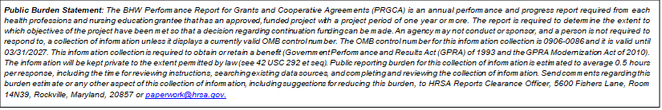**Instructions for Final Report for Grants and Cooperative Agreements**

# I. Purpose

The Final Report provides the Bureau of Health Workforce (BHW) with information required to close out a grant after you complete project activities. As such, every grantee must submit a final report after the end of their project. The Final report includes these sections:

* Project Objectives and Accomplishments
  + Description of major accomplishments on project objectives
* Project Barriers and Resolutions
  + Description of barriers/problems that impeded project’s ability to implement the approved plan
* Summary Information (optional)
  + Description of last approved grant project period including:
    - Project overview
    - Project impact
    - Prospects for continuing the project and/or replicating this project elsewhere
    - Publications produced through this grant activity
    - Changes to the objectives from the initially approved grant

# II. Final Report Submission Deadline

In addition to the final report, if we awarded your project a no-cost extension, you must provide the related performance data. The information, other than the performance data, should describe the entire project period – not just the final budget period.

You must submit your final report online within 120 days after the end of the project. We define the end of the project as the end of the final budget period, including any no-cost extensions.

# III. Final Report Instructions

**SECTION I. PROJECT OBJECTIVES AND ACCOMPLISHMENTS[1]**

List up to nine (9) project objectives (A-I) from your last approved grant project period; they should be the most important objectives for your project.

Present the objective and describe your accomplishments in each of them. Be concise; your response cannot exceed 5000 characters for each box.

We recommend that you prepare separate blocks of text for each description and accomplishment. This way you can “cut and paste” the text into our web-based data entry screens.

**Objective A**

Description of Objective

Accomplishments

**Objective B**

Description of Objective

Accomplishments

**Objective C**

Description of Objective

Accomplishments

# 

**SECTION II. BARRIERS & RESOLUTIONS[2]**

List up to nine (9) barriers/problems (A-I) that impeded your project’s ability to implement the approved plan (e.g., staffing, funding) from your last approved grant project period.

Describe the activities you have undertaken to minimize the effect of these barriers/problems. Be concise; your response cannot exceed 5000 characters for each box.

As above, the format will be the same for each barrier description and resolution.

**Barrier A**

Description

Activities Taken to Resolve

**Barrier B**

Description

Activities Taken to Resolve

**Summary Information (optional)**

# Technical Assistance

Recipients may need assistance when working online to submit their information electronically through HRSA’s EHBs. For assistance with submitting information in HRSA’s EHBs (i.e. technical system issues), contact the HRSA Contact Center, Monday-Friday, 8:00 a.m. to 8:00 p.m. ET:

HRSA Contact Center  
Phone: (877) 464-4772

TTY: (877) 897-9910  
Web: <http://www.hrsa.gov/about/contact/ehbhelp.aspx>

1. Note: awardees will have the ability to list up to 9 objectives and related accomplishments.
2. Note: awardees will have the ability to list up to 9 barriers and related solutions.